UNIX ass - 9
- fork and file descriptors Consider this code:
#include <stdio.h>
#include <stdlib.h>
#include <string.h>
#include <fcntl.h>
#include <unistd.h>

int main() {
int fd;
int pid;
char msg1[] = "Testing 1 2 3 ..\n";
char msg2[] = "Hello, hello\n";

if ((fd = creat("testfile", 0644)) == -1)
return 0;

if (write(fd, msg1, strlen(msg1)) == -1)
return 0;

if ((pid = fork()) == -1)
return 0;

if(write(fd, msg2, strlen(msg2)) == -1)
return 0;

close(fd);
return 1;
}

Test this program. After the call to fork, both processes have a file descriptor set to the same current position in the output file. How many messages appear in the file? What does the number of lines tell you about file descriptors and connections to files?

The testfile will have three lines. This indicates that after fork(), both parent and child processes share the same file descriptor, allowing each to write independently to the same file position. The two processes do not synchronize, leading to duplicate entries in the file.
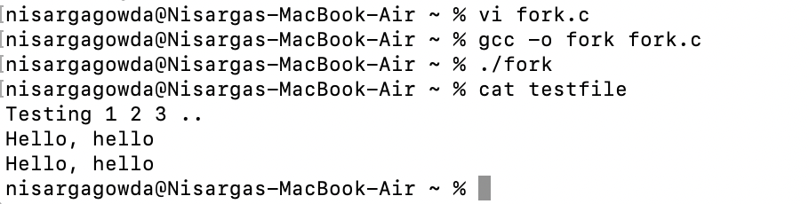

- fork and standard I/O Consider this code:

#include <stdio.h>

main() {
FILE *fp;
int pid;
char msg1[] = "Testing 1 2 3 ..\n";
char msg2[] = "Hello, hello\n";

if ((fp = fopen("testfile2", “w”)) == NULL)
return 0;
fprintf(fp, “%s”, msg1);

if ((pid = fork()) == -1)
return 0;
fprintf(fp, “%s”, msg2);

fclose(fp);
return 1;
}

---------------------------
#include <stdio.h>
#include <fcntl.h>
#include <unistd.h>
#include <stdlib.h>
#include <string.h>

int main() {
FILE *fp;
int pid;
char msg1[] = "Testing 1 2 3 ..\n";
char msg2[] = "Hello, hello\n";

if ((fp = fopen("testfile2", "w")) == NULL)
return 0;
fprintf(fp, "%s", msg1);

if ((pid = fork()) == -1)
return 0;
fprintf(fp, "%s", msg2);

fclose(fp);
return 1;
}

Test this program. How many messages appear in the file? Explain the results. Compare this program to the output of forkdemo1.c in the text.

Forkdemo1.c -263
#include ‹stdio.h›

main ( )
int ret_from_fork, mypid;
mypid = getpid() ;
printf ("Before: my pid is &d\n", mypid);
ret_from_fork = fork() ;
sleep (1) ;
printf ("After: my pid is %d, fork() said %d\n",
getpid(), ret_from_fork) ;
}
#include <stdio.h>
#include <stdlib.h>
#include <string.h>
#include <fcntl.h>
#include <unistd.h>

int main (){
int ret_from_fork, mypid;
mypid = getpid() ;
printf ("Before: my pid is %d\n", mypid);
ret_from_fork = fork() ;
sleep (1) ;
printf ("After: my pid is %d, fork() said %d\n", getpid(), ret_from_fork) ;
}

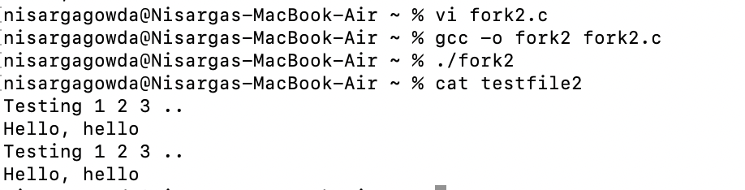

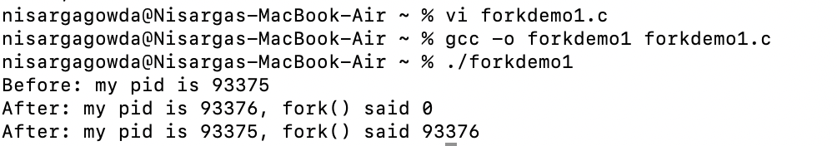

- Waiting for two children Expand the code in waitdemo1.c so that the parent creates two children and then waits until both children exit.
Expand your solution further so the program accepts an integer as a command-line argument. The program then creates that number of child processes and assigns each child a random number of seconds to sleep. Finaly, the parent process reports as each child exits.

Waitdemo1.c – pg 267
#include ‹stdio.h>

#define DELAY 2
main ( )
{

int newpid;
void child_code(), parent_code () ;
printf ("before: mypid is %d\n", getpid()) ;

if ( (newpid = fork ()) == -1 )
perror ("fork");
else if ( newpid == 0 )
child_code (DELAY) ;
else
parent_code (newpid) ;
}

void child_code (int delay)
{
printf("child %d here. will sleep for %d seconds\n", getpid(), delay) ;
sleep (delay) ;
printf ("child done. about to exit\n"):
exit (17) ;
}
void parent_code (int childpid)
{
int wait_rv;
wait_rv = wait (NULL) ;
printf("done waiting for %d. Wait returned: %d\n", childpid,
wait_rv);
}

Program:
#include <stdio.h>
#include <stdlib.h>
#include <unistd.h>
#include <sys/wait.h>
#include <time.h>

void child_code(int delay);
void parent_code(int num_children);

int main(int argc, char *argv[]) {
if (argc != 2) {
printf("Usage: %s <number_of_children>\n", argv[0]);
return 1;
}

int num_children = atoi(argv[1]);
if (num_children <= 0) {
printf("Please enter a positive integer for the number of children.\n");
return 1;
}

printf("Before: my pid is %d\n", getpid());

srand(time(NULL));

for (int i = 0; i < num_children; i++) {
int newpid = fork();
if (newpid == -1) {
perror("fork");
exit(1);
} else if (newpid == 0) {
int delay = rand() % 5 + 1;
child_code(delay);
}
}

parent_code(num_children);

return 0;
}

void child_code(int delay) {
printf("Child %d here. Will sleep for %d seconds.\n", getpid(), delay);
sleep(delay);
printf("Child %d done. About to exit.\n", getpid());
exit(17);
}

void parent_code(int num_children) {
int status;
for (int i = 0; i < num_children; i++) {
int childpid = wait(&status);
if (childpid == -1) {
perror("wait");
exit(1);
}
if (WIFEXITED(status)) {
printf("Done waiting for child %d. Exit status: %d\n", childpid, WEXITSTATUS(status));
} else {
printf("Child %d did not exit normally.\n", childpid);
}
}
}

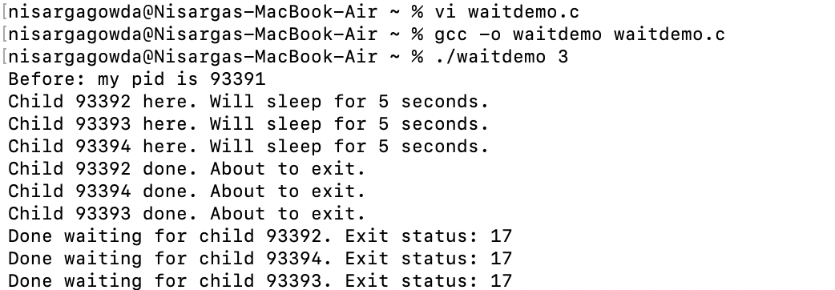

- Multiple SIGCHLDs Write a program that takes as an argument an integer and then creates that many child processes. All the children sleep for five seconds, then exit. The parent process sets a signal handler for SIGCHLD then enters a loop printing a message once a second. The handler calls wait and prints out the process ID of the child and increments a counter. When the counter reaches the original number of children, the program exits. Test this program for various numbers of children. The program is likely to miss some children as the number gets larger. Can you explain why it misses some signals? Is there a solution?

Create multiple child processes.
Each child sleeps for 5 seconds before exiting.
The parent process:
Sets a signal handler for SIGCHLD to handle child process termination.
Prints a message every second.
Waits for SIGCHLD and prints the child’s PID when the signal is received.

Why Some Signals Are Missed:
- Signal Queue Limitations: Operating systems often have a limited signal queue size. If many children exit quickly, some SIGCHLD signals may be lost.
- Signal Handling Delays: If the parent is not able to process signals quickly enough (due to system load or other factors), some signals may be missed.

Solution to Prevent Missing Signals:
- Use waitpid() in a loop inside the signal handler to handle multiple child process terminations.
- This ensures that the parent can reap all child processes, even if many exit at the same time, without missing any signals.

Key Steps in the Solution:
- Parent sets a SIGCHLD signal handler to handle child termination.
- Fork children: Each child sleeps for 5 seconds and exits.
- Signal handler: Inside the handler, use waitpid() in a loop to reap all terminated children.
- Parent prints a message every second while waiting for all children to exit.
- Exit condition: Once all children have exited, the parent exits.
#include <stdio.h>
#include <stdlib.h>
#include <unistd.h>
#include <sys/types.h>
#include <sys/wait.h>
#include <signal.h>

int child_count = 0;
int total_children;

void sigchld_handler(int sig) {
pid_t pid;
while ((pid = waitpid(-1, NULL, WNOHANG)) > 0) {
printf("Child with PID %d has exited.\n", pid);
child_count++;
}
if (child_count >= total_children) {
printf("All children have exited. Parent exiting...\n");
exit(0);
}
}

int main(int argc, char *argv[]) {
if (argc != 2) {
fprintf(stderr, "Usage: %s <number_of_children>\n", argv[0]);
exit(1);
}

total_children = atoi(argv[1]);

struct sigaction sa;
sa.sa_handler = sigchld_handler;
sa.sa_flags = SA_RESTART | SA_NOCLDSTOP;
sigaction(SIGCHLD, &sa, NULL);

for (int i = 0; i < total_children; i++) {
pid_t pid = fork();
if (pid == 0) {
sleep(5);
exit(0);
} else if (pid < 0) {
perror("fork failed");
exit(1);
}
}

while (1) {
sleep(1);
printf("Parent is running. Waiting for children to exit...\n");
}

return 0;
}
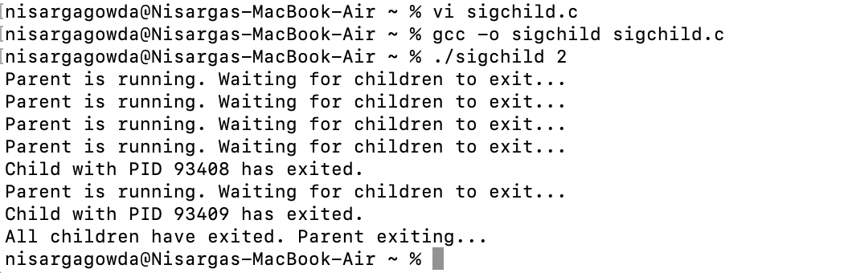
• Parent Process Running Message: The parent prints "Parent is running. Waiting for children to exit..." every second.
• Child Process Exit: After 5 seconds, each child exits, triggering the SIGCHLD signal and causing the signal handler to print the child’s PID (e.g., Child with PID 12345 has exited.).
• Completion: Once the parent has handled all child process exits (after reaping all children), it prints "All children have exited. Parent exiting..." and exits.

